RTEBMO1 - How to Check Rate Info

Find out more information about a Maestro rate, including rate characteristics, effective dates, included options/mileage etc. You can proceed to the next screen by pressing Enter to view all vehicle classes eligible for the rate.

Mandatory Fields:

ACTION: DISP
RATE ID: 2-character Maestro rate code (exclude the i-suffix)
STATIONS: 4-digit Maestro station number

Press Enter.

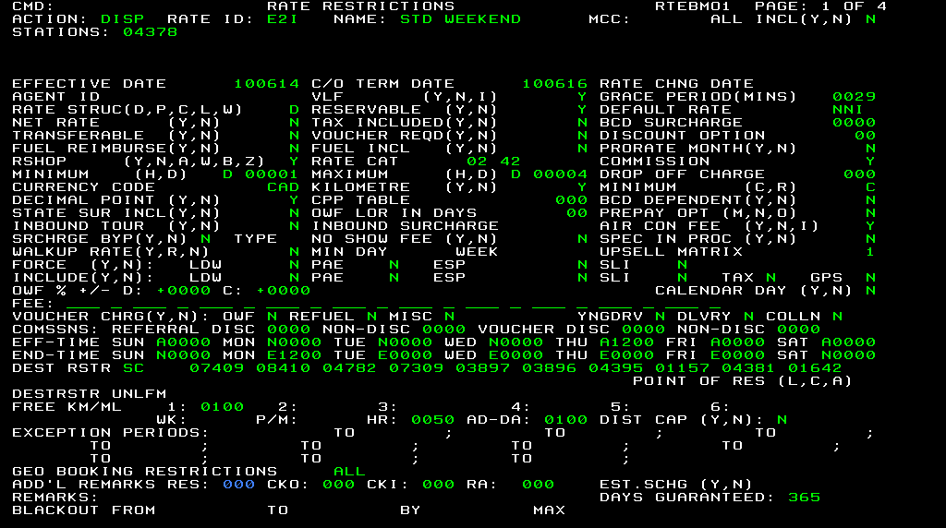

Note:

Understanding EFF-TIME and END-TIME in the RTEBMO1 screen.

A0000 – Can pick up vehicle anytime
AXXXX – Must pick up vehicle after XXXX (where XXXX is in 24-hr format)
N0000 – Can pick up/ return vehicle anytime
E0000 – Cannot return vehicle at all
EXXXX – Must return vehicle before XXXX (where XXXX is in 24-hr format)

With reference to the screenshot above, we know that E2I is available for rental if the vehicle if it is picked up AND dropped off according to the table below:

Pick Up | After 12PM on THU | FRI | SAT | SUN
Drop Off | Before 12PM on MON | SAT | SUN | -

